# NO:3

**AIM**: program to check whether number is even or not.

**Procedure:**

#!/bin/bash

read -p "Enter number to be checked " a

if(($a == 0))

then

echo "No is zero"

elif(($a % 2 == 0))

then

echo "No is even"

else

echo "NOT EVEN"

fi

**output:**

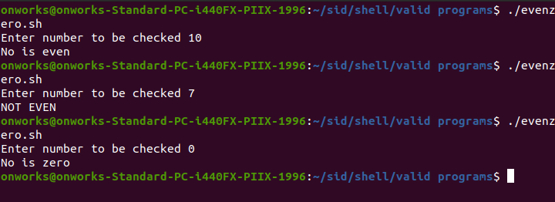

# Result

The program was executed and the result was successfully obtained. Thus CO3 was obtained